Are you or someone else from your family and friends are or going to be a victim of Diabetes type2 (T2D) (ref)? If not treated, it can turn into a crippling disease destroying your major body organs like heart, kidney, eye, foot, causing gum and other dental problems. It is nerve wrecking and scary.
It would be quite comforting if you can reverse diabetes 2 and come back to the non-disease state. But can you?
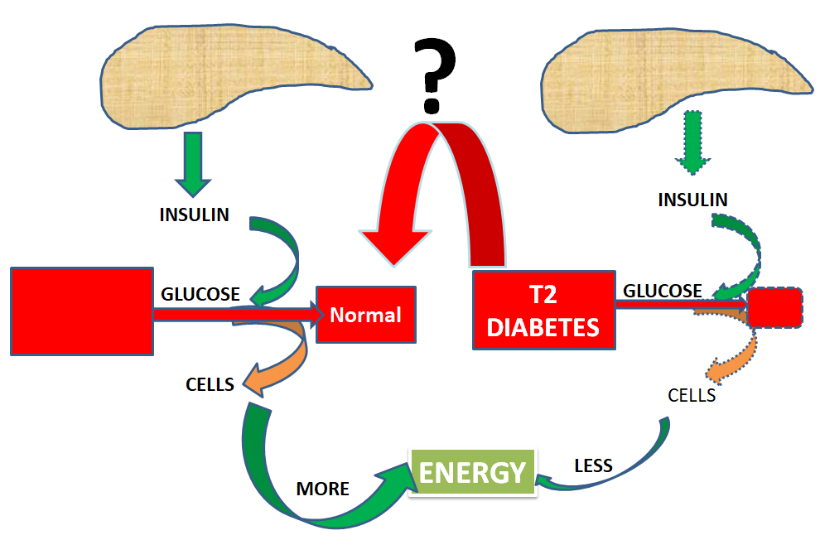
Early on, it was believed diabetes is not reversible because the cells of the pancreas that produces insulin are dead when diabetes occurs. However research study found there are some cells in the pancreas which are still active even if you have the disease. The good news is with proper diet, exercise and change of life style and even surgery the pancreatic cells could be made active, functional and can be triggered to regenerate.
Let’s delve in.

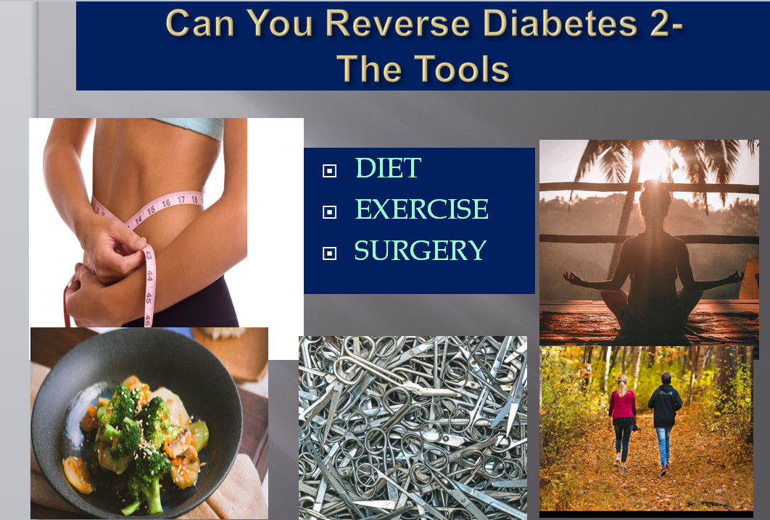

Diet

“What you eat is what you are”. Every word of it is for type 2 diabetes. Fasting seems to be a no brainer when you are thinking of decreasing your obesity which is deeply connected with diabetes. But it never means a diabetic can’t be skinny or of normal weight.
Ketogenic diet potentially Reverses Diabetes 2
Clinically prescribed https://www.ncbi.nlm.nih.gov/pubmed/31336509 ketogenic diet along high intensity interval training exercise, 45 min psychotherapy and Education on nutrition was offered to patient.
These set of treatment regimen offered statistically significant results after 12 weeks.
- HA1c was out of diabetes range.
- Daily glucose declined from 216 mg/dl to 96 mg/ dl.
- Insulin resistance and triglyceride/HDL improved by 75%.
The authors comprehend this 65 year old patient suffering from diabetes for 26 yers and mentally depressed got empowered with a new life.
Intermittent Fasting https://www.ncbi.nlm.nih.gov/pmc/articles/PMC6194375

Refrain from all calorie containing food and drink for a species period of time ranging from 16 h to several days. It depends on patient’s preference.

Patient could drink unlimited amount of water and very low calorie fluid like tea and coffee.

Eat a low in refined carb and low sugar diet which decreases blood glucose and insulin.
- A 24 hour fasting regimen can significantly reverse or even eliminate the need for medication.
In a study, a 52 year old man living with type2 diabetes for 14 years and suffering from Gastric problem as a side effect of metformin medication was put on a low carb diet regimen.
- The patient lost 16 Kg over 7 month period,
- Reduced BMI
- Reduced HA1c
- The person achieved the goal of being medication free while maintain blood sugar control.
- Reversed insulin resistance.
A practical dieting strategy of blood glucose control can be set with medically supervised fasting with adequate patient education.
Effect of Very low calorie diet on blood glucose control
https://www.ncbi.nlm.nih.gov/pubmed/30918654
In a 2019 study, -50 years old obese patients (BMI =27.7 Kg/m2) were given 600 kcal/ day diet for 8 weeks followed by a transition period of 4 weeks. They showed 79% remission without any glucose lowering medication at 4 weeks vs. only -30% after 12 months.
A very low calorie diet was effective in short term
- Significant reduction in body weight
- significantly reducing insulin resistance,
- Activating beta cells to increase insulin production
- 1/3rd of the patients maintained the remission after 12 weeks without any medication
- Increased quality of life
There are multiple other larger showing the effectiveness of diet control contributing to declining blood sugar and HA1c level.
Exercise
Diet and exercises are the corner stone of diabetes management.
Exercise by itself might not help control blood glucose or HA1c, but with diet it contribute positively toward helping reversal of diabetes. Walking, biking, jogging, high intensity interval training exercises are in mainstream fot diabetes control.
Walking has been known as a simple way to control the blood glucose. However, it can’t reverse diabetes by itself.
It is natural, free of cost and carry less chance of being injured to realize big benefits.
- A minimum of 30 min brisk walking (100 steps in one minute) every day most days of the week or 180 min in a week can work. You may split the 30 min to 3 of 10 min slots.
- Walking 15 min right after your main meals can help the blood sugar spikes and help stabilize sugar levels.
High intensity interval training exercises positively impact blood glucose and HA1c control in diabetic situation.
You can have your personal trainer at gym to help you reduce body weight by designing exercise. Other exercises can help diabetes situation.
- Squat
- Skipping
- Leg raising
- Super jumps
Yaga: Kapalvati pranayam help lose fat from liver and pancreas
https://food.ndtv.com/health/kapalbhati-pranayam-how-to-do-it-steps-and-benefits-1414298
https://www.ncbi.nlm.nih.gov/pmc/articles/PMC4959327/
Kapalabhati is proven to directly stimulate the pancreas to release insulin and counteract an excess of glucose in the blood stream.
Regular practicing of Kapalvati reduces subcutaneous fat resulting in improvement of BMI.
The abdominal stretching which occurs during Kapalbhathi helps in the regeneration of pancreatic cells. This in turn supplies glucose to tissues resulting in blood sugar reduction.
https://www.semanticscholar.org/paper/The-Role-of-Physical-Exercise-and-Diet-Modification-Mishra/33d0aadadccd2f57da5d22e694e616631878a804; a clinically diagnosed diabetes 2 group (suffering from type2 diabetes for 5 years) using diet and Yogic exercise as the tools for blood sugar and diabetes control exhibited better level blood sugar control compared to a control group with oral anti-diabetes medication.
Surgery https://www.ncbi.nlm.nih.gov/pmc/articles/PMC6520897
Although lifestyle modifications are universally acknowledged to be the first-line treatment of T2D, adequate glycemic control is difficult to achieve in majority of obese patients.
Bariatric Surgery: It is weight loss surgery and is done on stomach or intestine. Reversal is achievable by surgery for 7/10 obese patients
- It is an effective treatment option for obese patients with T2D, but is invasive, costly and not without its risks.
- Long-term effects have not been definitively established, and failure of the surgical intervention may occur due to non-compliance with diet and lifestyle factors.
- In addition, many patients require surgical reversal. Medications help manage the symptoms of diabetes, but they cannot prevent the progression of the disease.

Can Vit-d help reverse type 2 diabetes?

Patients with Type 2 diabetes had a 78.5% Vitamin-D level <30 ng/m. People deficient in vitamin-d are prone to develop diabetes type 2. https://www.ncbi.nlm.nih.gov/pmc/articles/PMC5872793/Vitamin D supplementation was shown to increase serum 25(OH)D and reduce insulin resistance effectively. This effect was especially prominent when vitamin D was given in large doses and for a short period of time, and to patients who were non-obese, vitamin D deficient.

My primary care physician Dr. Elangovin recognized the extreme vitamin d deficiency (4 ng/ml) in my blood analysis and connected it with diabetes 2 (link about me page). I was prescribed with 50000 IU of vit d once/week for 6 months. I saw huge improvement in my hemoglobin A1c no and other benefits along with good improvement of vit d level.
Vitamin d receptors are present throughout the body. It is suggested that Vit d interact with insulin sensitive receptor, increase their no. and helps boosting insulin sensitivity.
Everyone is different. So advice from your doctor is essential to assess your situation.
Optimal Vit D may not be able to reverse diabetes situation but it definitely help in prevention and progression of the disease.
Caution!
Www.fda.gov
Be aware of illegally Marketed Diabetes treatments- FDA`
Does it sounds too good to be true?
Then probably it is a scam. Watch out for these and similar red flags
- “Lowers blood sugar naturally!’”
- “Inexpensive therapy to fight and eliminate type 2 diabetes!”
- “Protects your eyes, kidneys, and blood vessels from damage!”
- “Replace your diabetes medicine!”
- “Effective Treatment to relieve all symptoms of diabetes!”
- “Natural diabetes cure!”
Diabetes is a chronic condition but let the scammers fool you. Stay with your physician and take their advice during your treatments.
Summary
Diabetes type 2 reversal is achievable
- bariatric surgery
- Gastric bypass surgery
- Diet and exercise
- Optimal Vitamin D level helps improve disease conditions

Meta: Find the science based answers to ‘’ Can you reverse diabetes 2? “. Learn how diet, exercise and surgery work as solution to these sets of chronic syndrome.

